**L21-7512 Abdullah Dar CN lab no 3 BSCS-5G1**

**PART 1**

**Question no 1:**

**1- List up to 4 different protocols that appear in the protocol column in**

**the unfiltered packet-listing window.**

**ANSWER:**

SNMP, DNS, TCP, HTTP

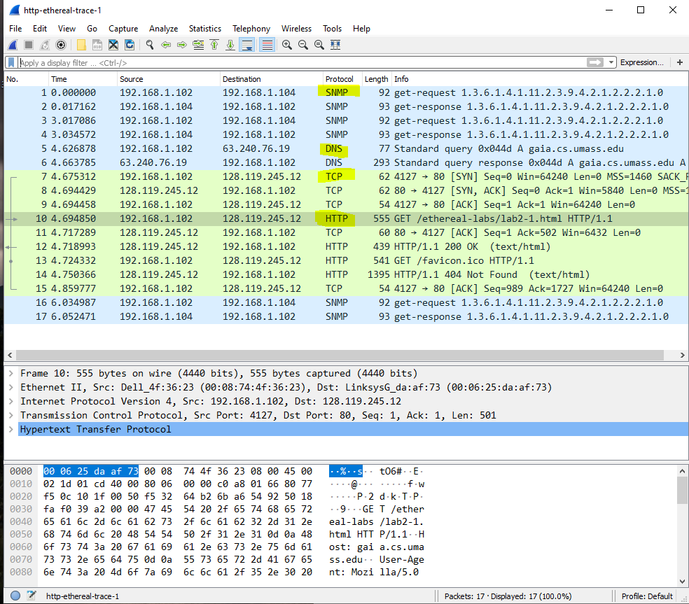

**-------------------------------------------------------------------------------------------------------------------------------------- Question no 2:**

**How long did it take from when the HTTP GET message was sent until**

**the HTTP OK reply was received?**

**ANSWER:**

**TIME = 4.718993 - 4.694850 = 0.024143**

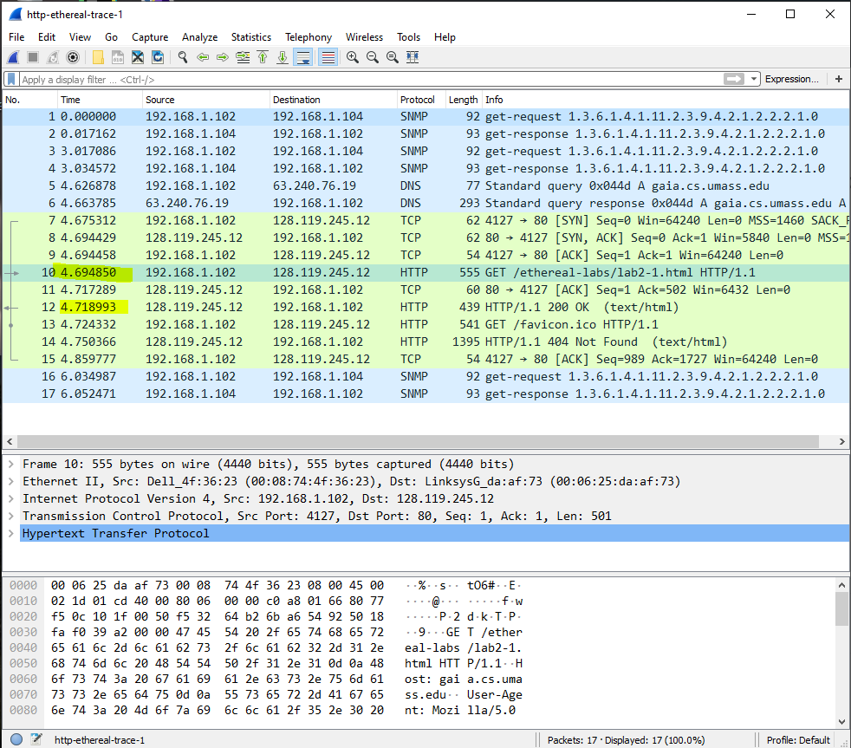

**-------------------------------------------------------------------------------------------------------------------------------------Question no 3:**

**Was the second Get Request successful? How can you tell it from the**

**corresponding response packet?**

**ANSWER: NO GET REQUEST WAS NOT SUCCESSFUL**

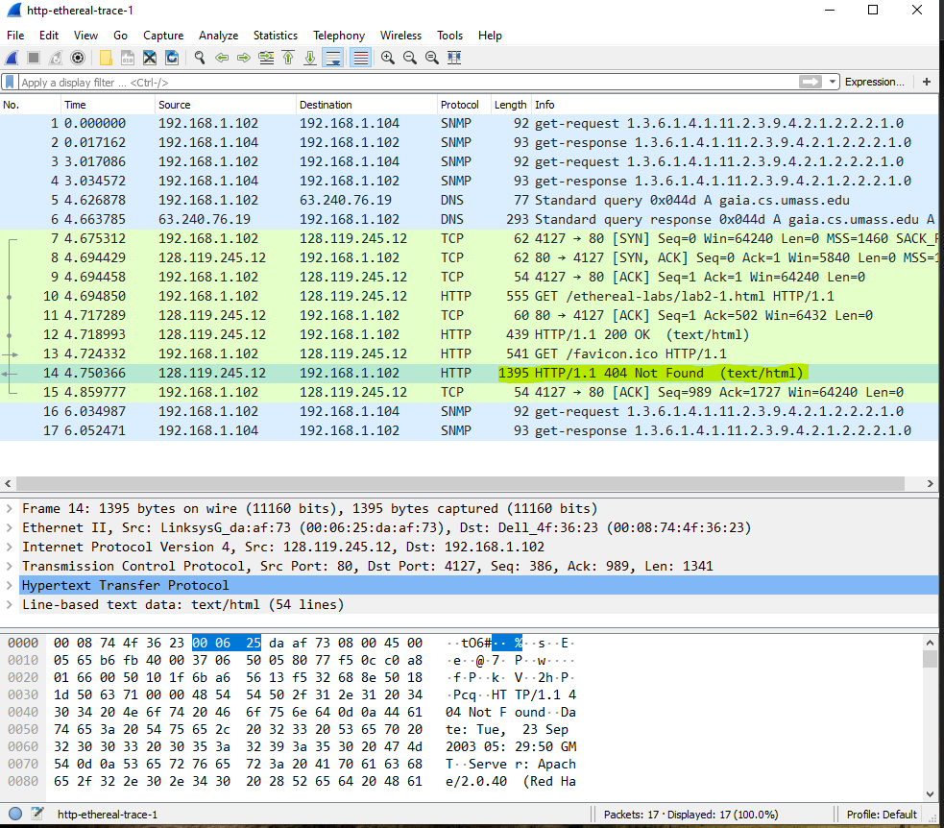

**-------------------------------------------------------------------------------------------------------------------------------------Question no 4:**

**Is your browser running HTTP version 1.0 or 1.1? What version of**

**HTTP is the server running?**

**ANSWER: HTTP VERSION IS 1.1**

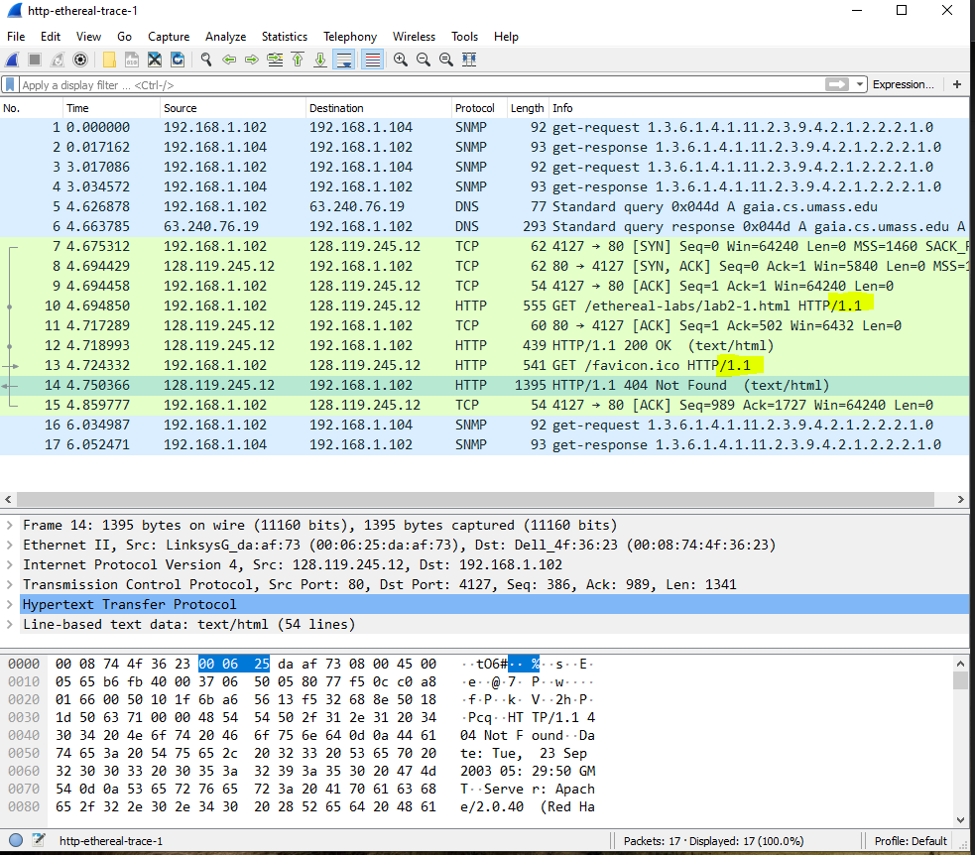

**-------------------------------------------------------------------------------------------------------------------------------------Question no 5:**

**What languages (if any) does your browser indicate that it can accept**

**to the server?**

**ANSWER: Accept-Language: en-us, en;q=0.50\r\n**

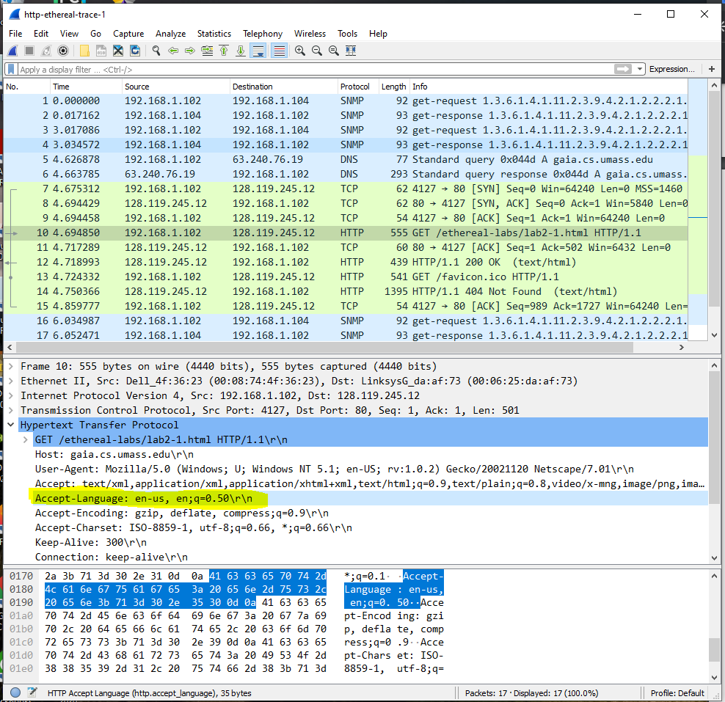

**-------------------------------------------------------------------------------------------------------------------------------------Question no 6:**

**What is the IP address of the gaia.cs.umass.edu server and your**

**computer?**

**ANSWER:**

**Src: 192.168.1.102**

**Dst: 128.119.245.12**

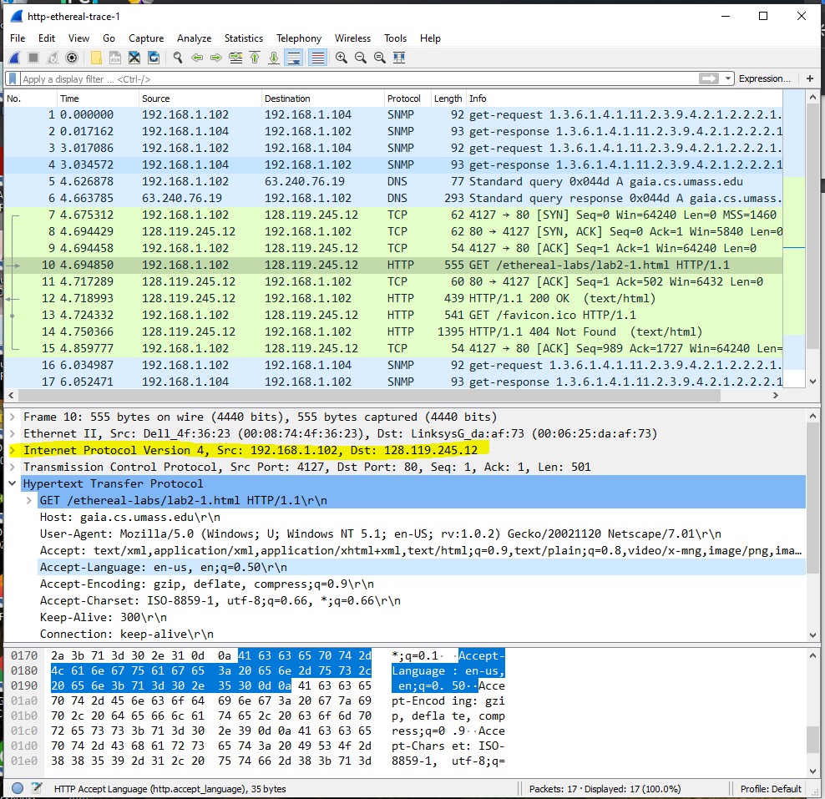

**-------------------------------------------------------------------------------------------------------------------------------------Question no 7:**

**What is the MAC address of the server and your computer?**

**ANSWER:**

**Destination: LinksysG_da:af:73 (00:06:25:da:af:73)**

**Source: Dell_4f:36:23 (00:08:74:4f:36:23)**

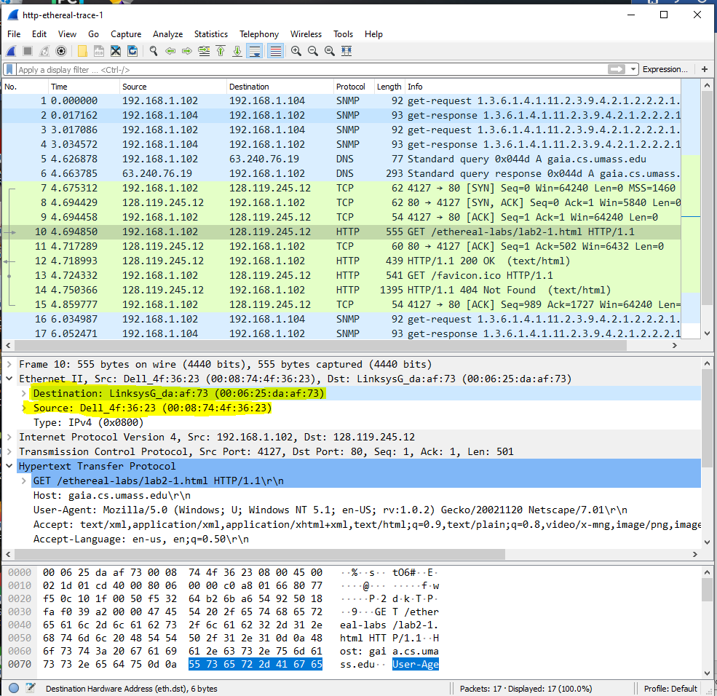

**-------------------------------------------------------------------------------------------------------------------------------------Question no 8:**

**What is sending and receiving Port Number? What does Port No. 80**

**represents?**

**ANSWER:**

**Source Port: 80**

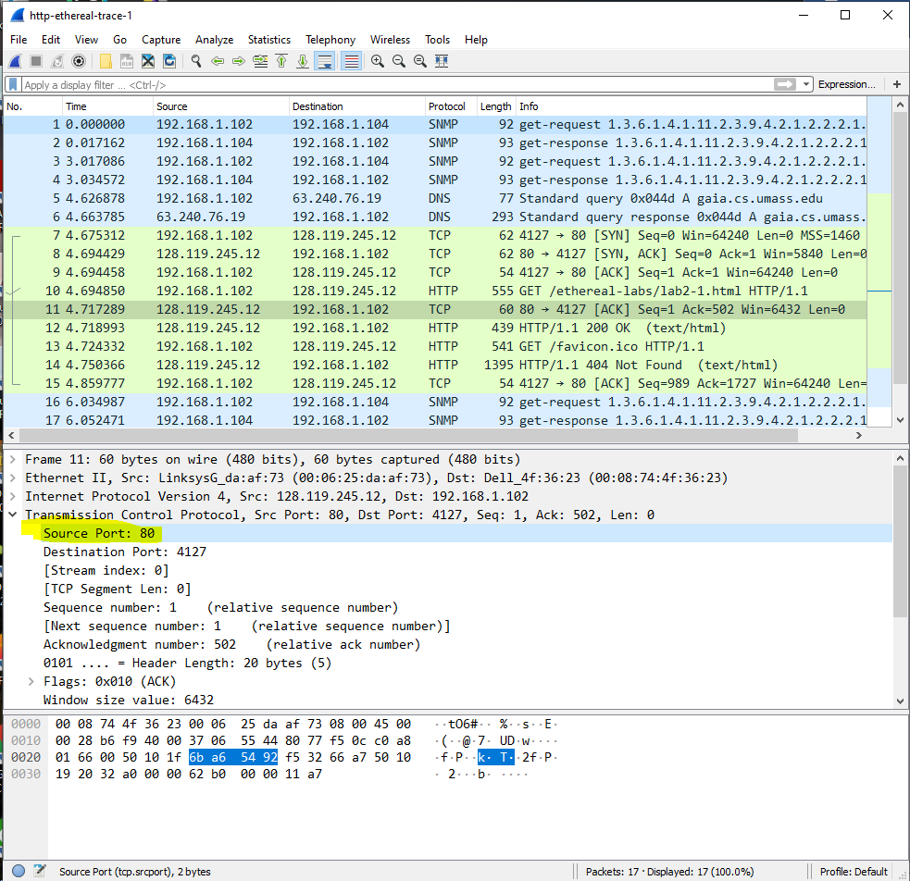

**-------------------------------------------------------------------------------------------------------------------------------------Question no 9:**

**What is the status code returned from the server to your browser?**

**ANSWER:**

**Status Code: 200**

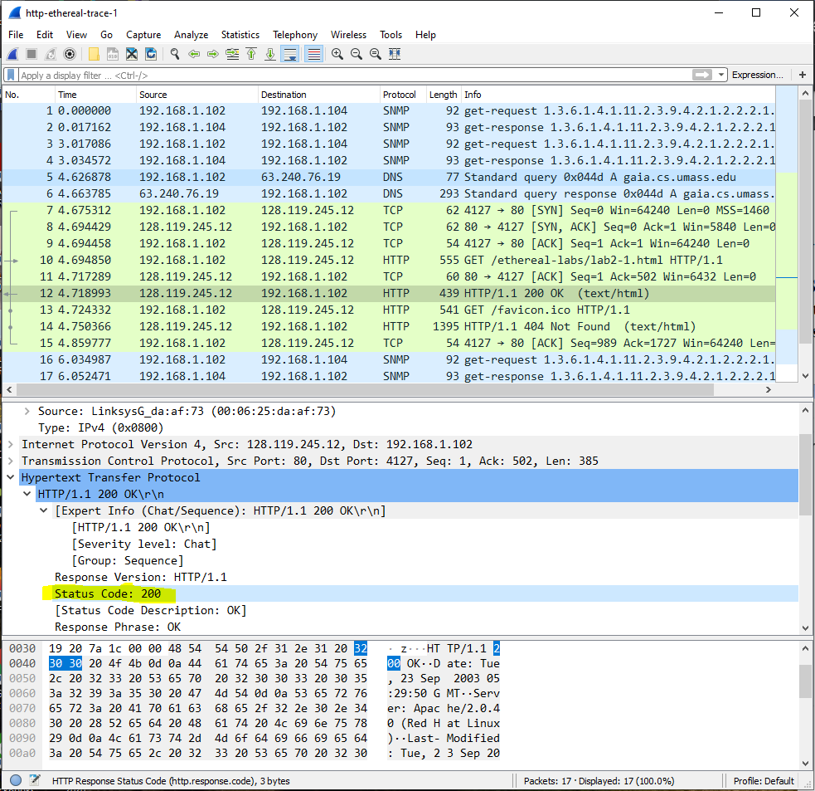

**-------------------------------------------------------------------------------------------------------------------------------------Question no 10**

**When was the HTML file, that you are retrieving, last modified at**

**the server?:**

**ANSWER: Last-Modified: Tue, 23 Sep 2003 05:29:00 GMT\r\n**

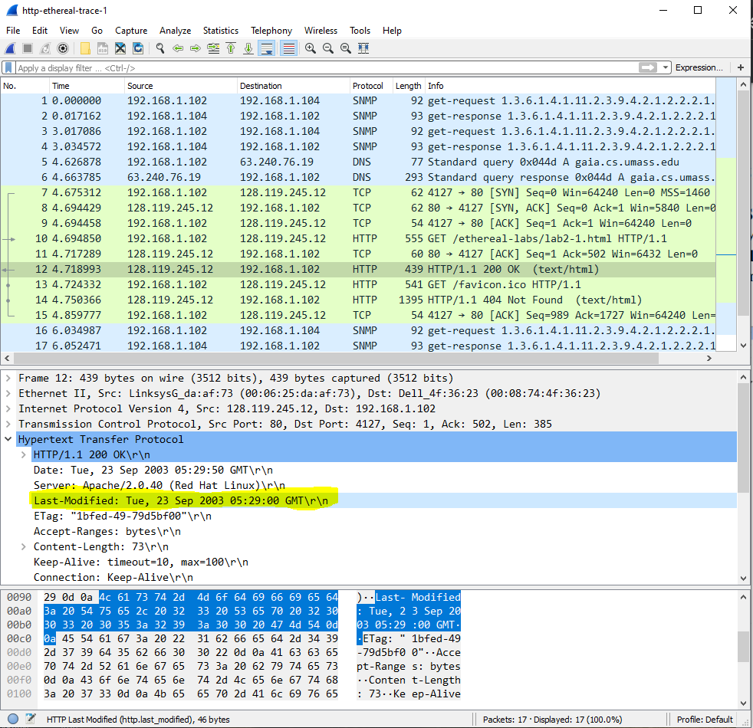

**-------------------------------------------------------------------------------------------------------------------------------------Question no 11:**

**How many bytes of total packet content are being returned to your**

**browser?**

**ANSWER:**

**Content-Length: 73\r\n**

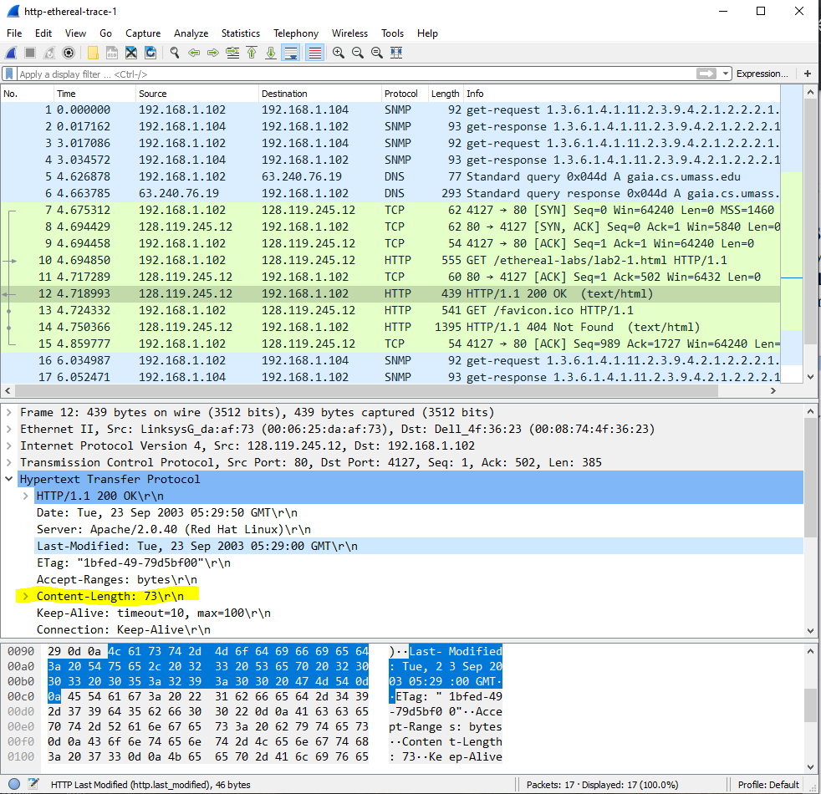

**----------------------------------------------------------------------------------------------------------------------------------------------------------------------------------------------------------------------------------------------------------------------------**

**PART 2**

**-------------------------------------------------------------------------------------------------------------------------------------Question no 1:**

**Inspect the contents of the first HTTP GET request from your browser to**

**the server. Do you see an “IF-MODIFIED-SINCE” line in the HTTP GET?**

**ANSWER:**

**There is no IF-MODIFIED-SINCE in the frist get http**

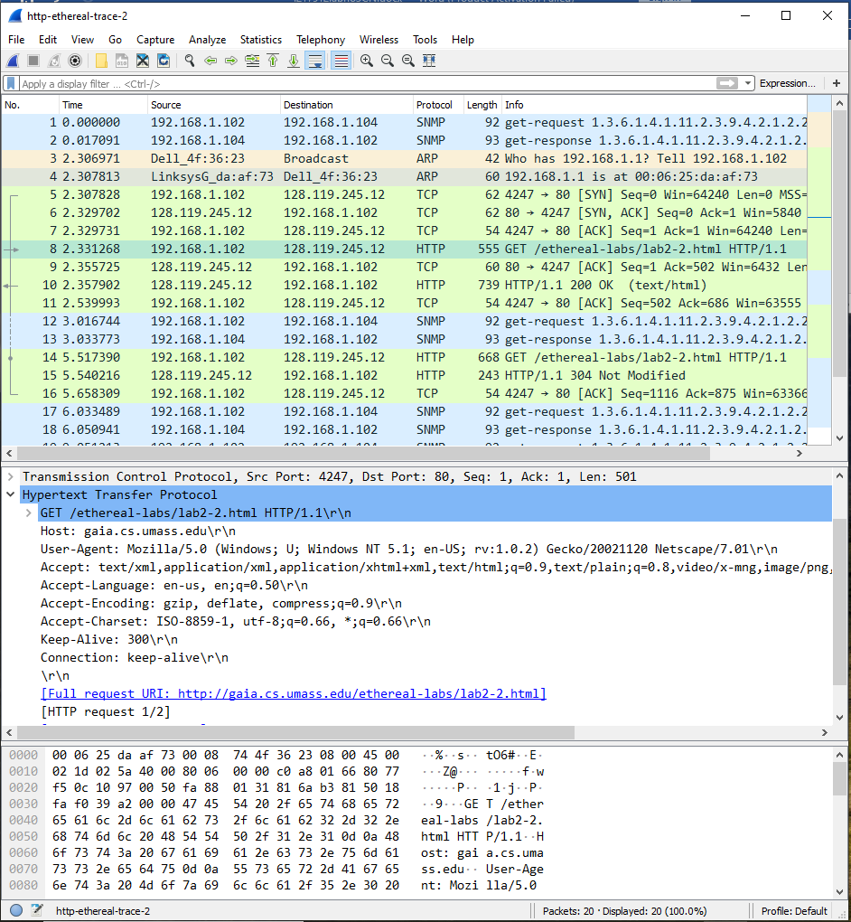

**-------------------------------------------------------------------------------------------------------------------------------------Question no 2:**

**Inspect the contents of the server response. Did the server explicitly return**

**the contents of the file? How can you tell from the Packet Bytes Window?**

**ANSWER:**

**Yes, the server explicitly returned the contents of the file. I am able to tell this because of the Line-based text data in the OK response to the GET.**

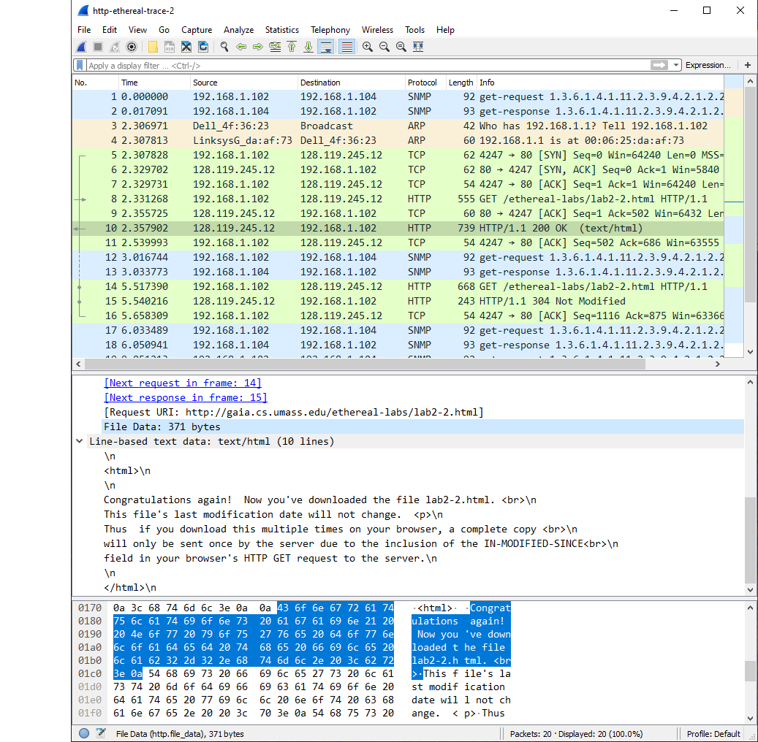

**-------------------------------------------------------------------------------------------------------------------------------------Question no 3:**

**Now inspect the contents of the second HTTP GET request from your**

**browser to the server. Do you see an “IF-MODIFIED-SINCE:” line in the**

**HTTP GET? If so, what information follows the “IF-MODIFIED-SINCE:”**

**header? What is meant by this information?**

**ANSWER:**

**An “IF-MODIFIED-SINCE:” line in the HTTP GET was present. The information that followed the “IF-MODIFIED-SINCE:” header that was not present in the other HTTP GET was the date it was modified, a match query, and a cache-control (I suppose this is part of why the cache had to be cleared first).**

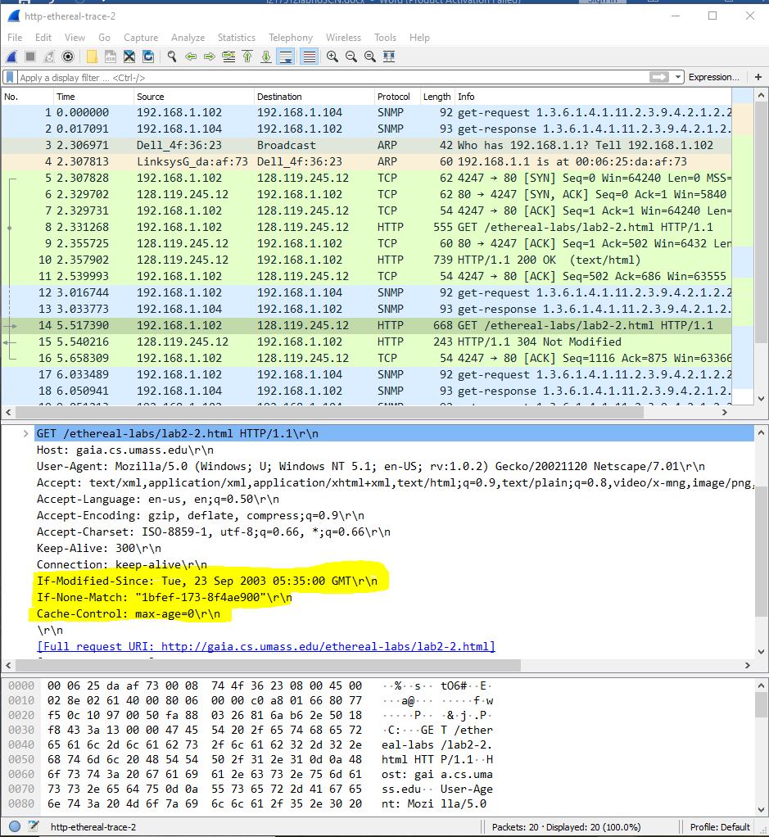

**-------------------------------------------------------------------------------------------------------------------------------------Question no 4:**

**What is the HTTP status code and phrase returned from the server in**

**response to this second HTTP GET? Did the server explicitly return the**

**contents of the file? Explain your answer**

**ANSWER:** **The HTTP status code that the server responded with was a 304 NOT MODIFIED.** **This means that the server explicitly returned the contents of the file.**

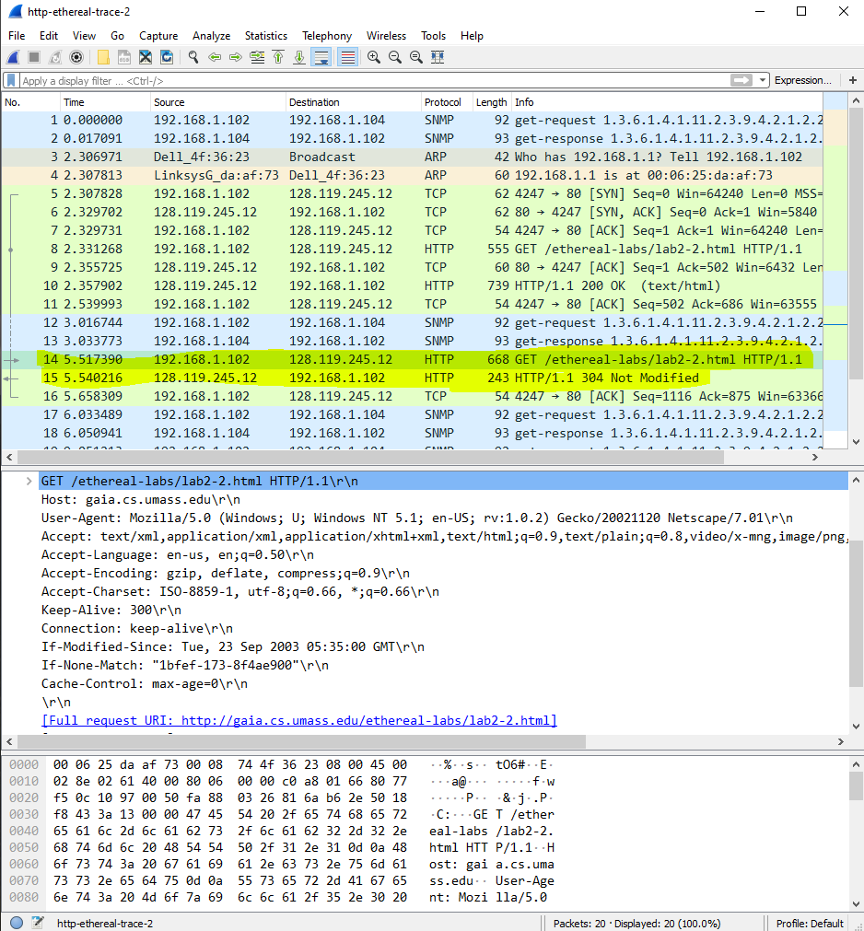

**-------------------------------------------------------------------------------------------------------------------------------------Question no 5:**

**How many HTTP GET request messages did your browser send?**

**ANSWER: HTTP SENT ONLY ONE GET REQUEST**

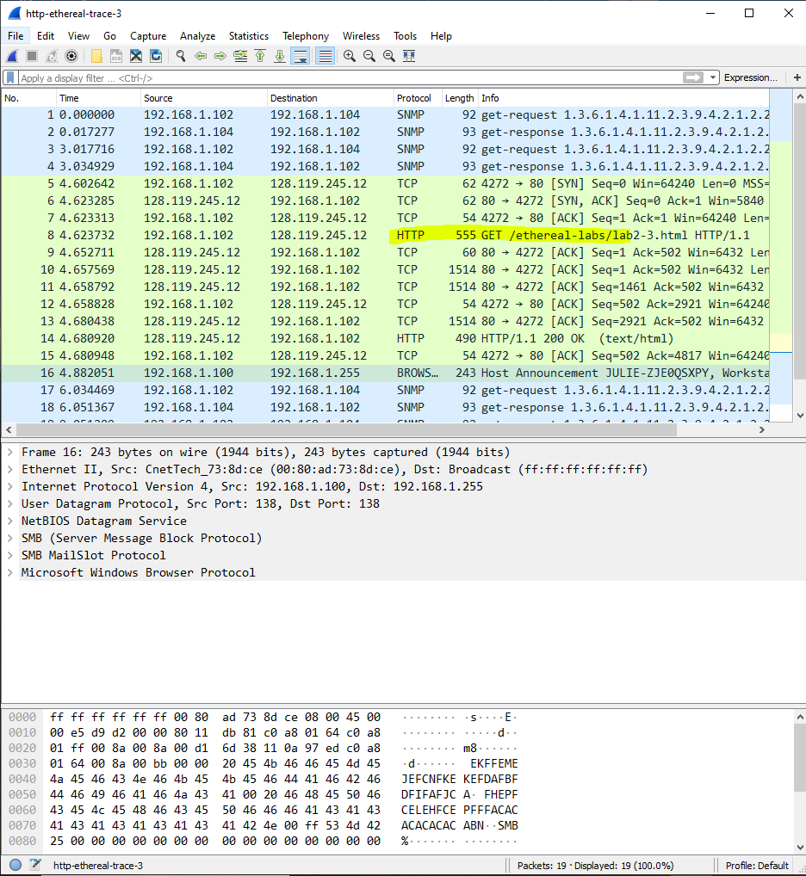

**-------------------------------------------------------------------------------------------------------------------------------------Question no 6:**

**Which packet number in the trace contains the GET message for The Bill**

**of Rights?**

**ANSWER: PACKET NO 8 contains the get message for the bill of rights**

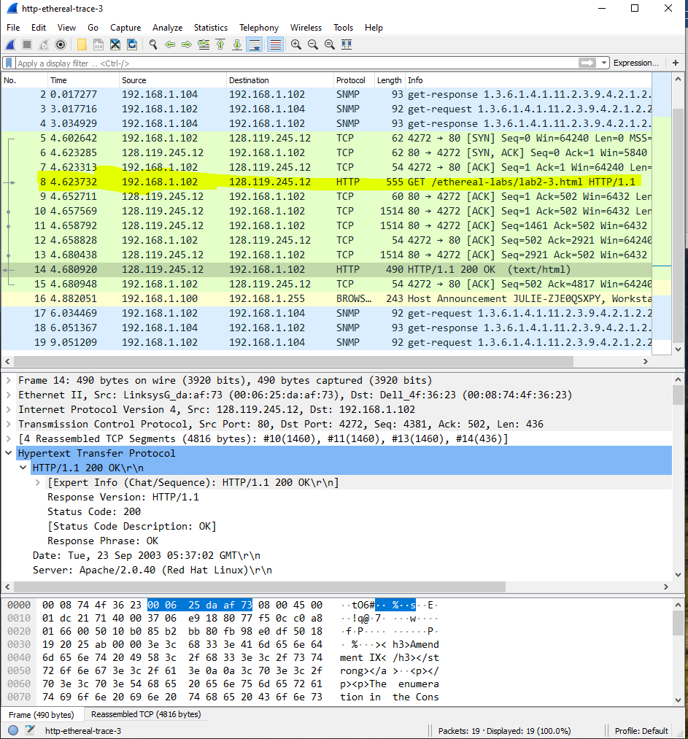

**-------------------------------------------------------------------------------------------------------------------------------------Question no 7:**

**Which packet number in the trace contains the status code and phrase**

**associated with the response to the HTTP GET request?**

**ANSWER: Packet 14 contained the response to the HTTP GET request.**

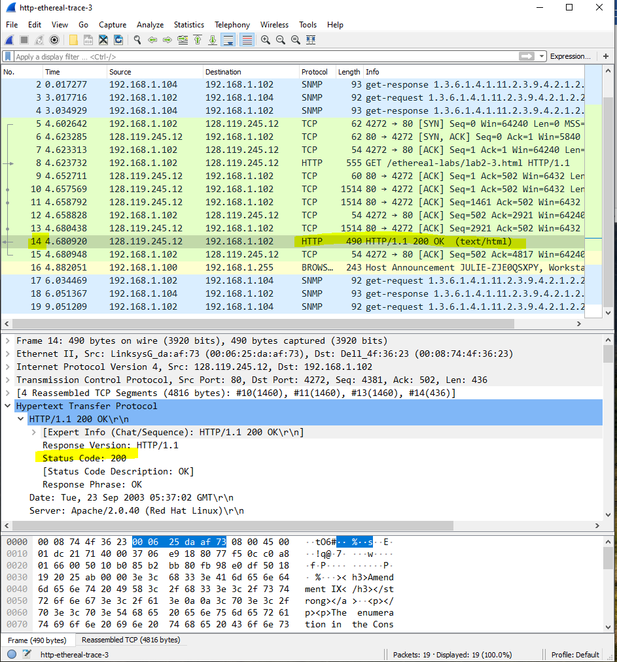

**-------------------------------------------------------------------------------------------------------------------------------------Question no 8:**

**What is the status code and phrase in the response?**

**ANSWER:**

**Status Code 200**

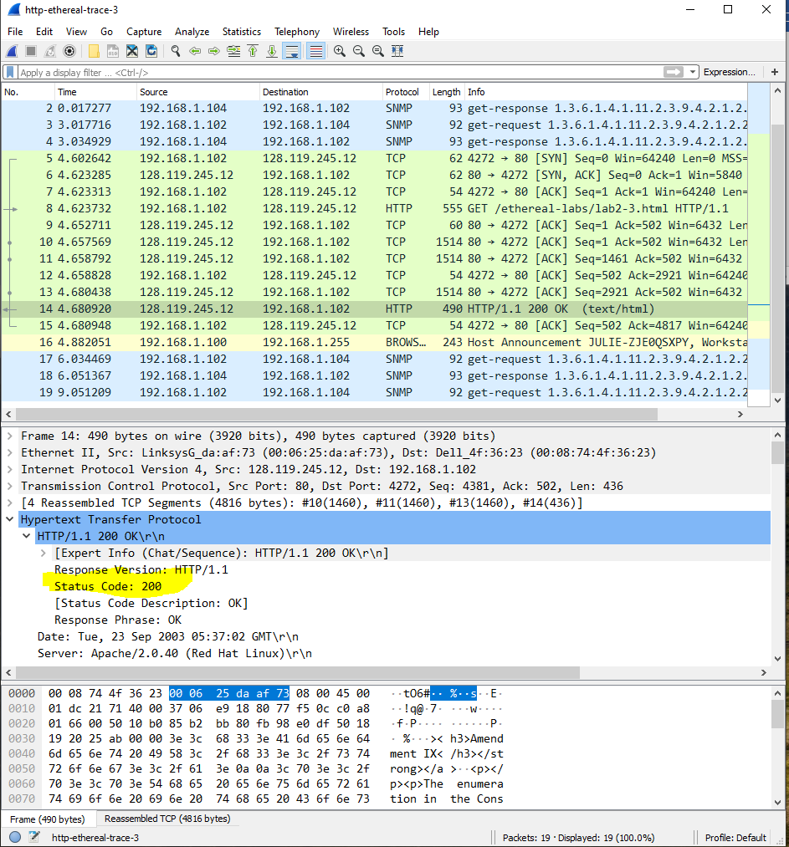

**-------------------------------------------------------------------------------------------------------------------------------------Question no 9:**

**How many data-containing TCP segments were needed to carry the single**

**HTTP response and the text of the Bill of Rights? What are the numbers of**

**those packets?**

**ANSWER:**

**4 data-containing TCP segments were needed to carry the single HTTP response and the text of the Bill of Rights.**

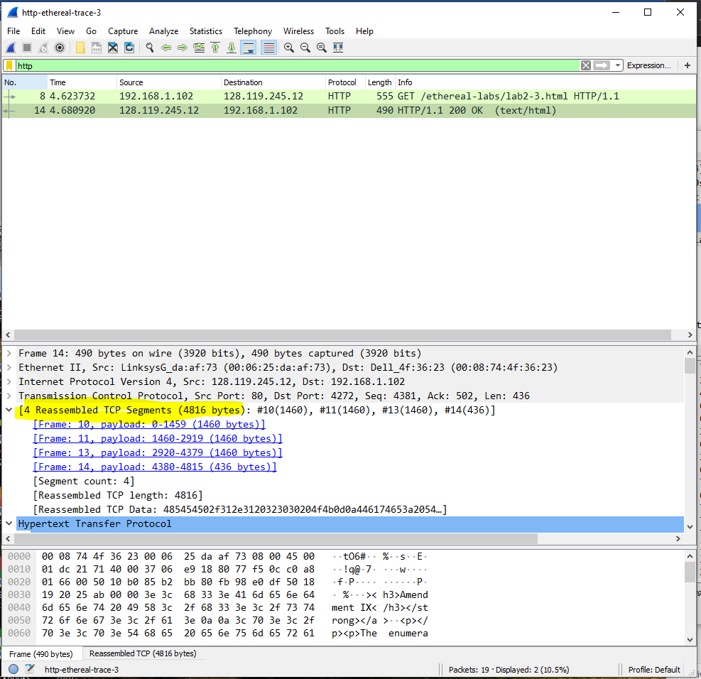

**--------------------------------------------------------------------------------------------------------------------------------------**

**In-Lab Statement 3: Trick Question (10)**

**What is the length of the text for The Bill of Rights in bytes? How do**

**you justify this length of text when your Response Packet Size is only**

**490 bytes? Give complete explanation how the length of text in various**

**packets add up to a total of 4500 Bytes.**

**ANSWER:**

**LENGTH OF TEXT FOR THE BILL OF RIGHTS IN BYTES IS 4500 bytes.**

**4 packets are transferred.**

**On the system its showing 4815 bytes because of the header files that are placed on them during transfer. Last packet size is small because it contains the remaining data that cannot be fitted in second last packet**

